

University of
North Alabama

Getting Your Canvas Course

Ready for Students

Getting Your Canvas Course

Ready for Students
This document contains some helpful resources and quick guides for common Canvas usage. This is a great resource for those who are new to Canvas or need a quick refresher. For more detailed or troubleshooting assistance, please refer to the Canvas Instructor Guides or request help by contacting Canvas Support..

Quick Start Check for the First Week of Classes

Here are some common “getting started” things to do prior to the first day of class:
- Log into Canvas at una.instructure.com using your UNA username and Password
  - It is also possible to access Canvas by going to the UNA webpage (una.edu) and clicking the “Canvas” option at the top

- Create/Upload your Syllabus in Simple Syllabus
- Add Modules and Course Content as needed: Pages, Assignments, Quizzes, Discussions
- Check the Grade Posting Policy settings
- Preview your course with Student View to ensure that it looks correct on the students’ end
- Make the course available to students by Publishing the course
- Post a welcome announcement using Announcements -or- Send a welcome message to students using Canvas Inbox


Common Pitfall: Publishing, Course Dates, and Messaging
Even if the course is published, students may be unable to access it if the course start date has not been reached or if course access is restricted. Always double-check both the publish status and the course date settings.

Additionally, a course must be published before students can receive announcements and Canvas Inbox messages.

Getting Started with Canvas

New to Canvas or need a refresher? Here are the primary resources for all things Canvas:
- Canvas also provides a two Canvas apps for use on mobile devices: Canvas Teacher (iOS/Android) and Canvas Student (iOS/Android).
  - While Canvas does provide mobile apps, instructors are primarily able to create and edit course content through the web version of Canvas.
- The official video conferencing/meeting software of UNA is Microsoft Teams. Microsoft Teams is part of the Office 365 package that all UNA faculty and staff receive.
- For more in-depth guides on Canvas usage, please visit the Canvas Guides for help:
  - Canvas Basics
  - Instructor Getting Started Resources
  - Instructor Resources
  - Student Resources
  - Canvas Studio
  - Canvas Commons (Learning Objective Repository)
- Set up your profile and notification preferences
- Customize your Dashboard to select which courses appear
- Add nicknames and images to your course cards for easier identification

Communicating with Students

Here are some important guides and considerations for when communicating with students:
- Send Course Announcements to broadcast important updates to the class
- Use the Canvas Inbox for direct messaging with students
  - Send messages to individual students or the entire class
  - Use “Send an individual to each recipient” to prevent users from seeing who else is being messaged. This is the equivalent of blind carbon copy (BCC).
  - Preview your course using Student View to confirm visibility

Common Pitfall: Canvas Messaging
Your course must be published before students can receive announcements and Canvas Inbox messages.

Canvas messages are plain text only. While you can reply to emails forwarded from Canvas to an external email (such as your UNA email), you can only add attachments within the Canvas Inbox (i.e., you cannot add attachments from Outlook). Attachments made to replies made outside of Canvas Inbox will not be transmitted to Canvas and will not be added to the email thread.

Creating Course Materials

Here are some great resources for creating, editing, and importing content in your course:
- Copy/Import content from other courses
  - You can only import course content from courses you are listed as the instructor.
  - To avoid importing multiple times, please be patient! Importing is requested through the Canvas system that provides support with all institutions that use Canvas. Depending on the request load and time of year, it can take several minutes to a few hours for the import to finish.

Sharing Course Content with Colleagues
Need to share Canvas content with colleagues? There are three options for sharing:

- Sharing individual content. Use the Direct Share feature to share an individual content item such as a page, quiz, announcement, etc.
- Export and Share via OneDrive. If you need to share a large portion or the entirety of a course, you can export your course and use OneDrive to share it
- Share via Commons. Publish your course or Canvas content (e.g., module, page, quiz, announcement, etc.) to your program/departmental Commons account in Canvas to share with colleagues.

- Adjust assignment due dates in bulk
- Use Modules to organize materials (e.g., pages, assignments, quizzes, discussions, etc.) and external content/links
  - You can duplicate entire modules or individual items
- Create Pages, Assignments, Discussions, and Quizzes/Exams as needed
  - Use “No Submission” for offline or external activities
  - If needed, enable Turnitin to detect plagiarism
  - Create rubrics for your assignments to promote the consistency of grading and decrease the time needed to grade assignments.
  - Most assignments are assigned to the entire class. However, it is possible to assign items to individual students.
- Hide unused navigation items in the course menu for a cleaner student view
- Decide if you want to use the Attendance Tool (Roll Call) – and if you want attendance to count toward the final grade.
- Create/Upload your Syllabus in Simple Syllabus
- Consider adding a brief mid-term evaluation to your course. These evaluations can be short 3-5 question surveys about the course learning experience to help guide your teaching strategies. While you can use a variety of survey tools, the Canvas quiz tool can be used to create surveys (both graded and ungraded) and allow responses to be anonymous!

Common Pitfall: Canvas Storage and Course Content
Canvas courses have limited storage. Uploading large files such as lecture videos and PowerPoints can quickly hit storage capacity. Instructors are strongly encouraged to share videos through Canvas Studio (Module or Page sharing) and all other content through OneDrive (also called Office 365) as these methods do not affect storage.

*If you are using OneDrive for the first time in Canvas, you will be prompted to log into your Microsoft Account using your UNA credentials to sync your Canvas and Microsoft accounts. You will only need to do this the first time. Once logged in, this feature will be available in all of your Canvas courses.

Add OneDrive File to Page, Assignment, Discussion, etc.
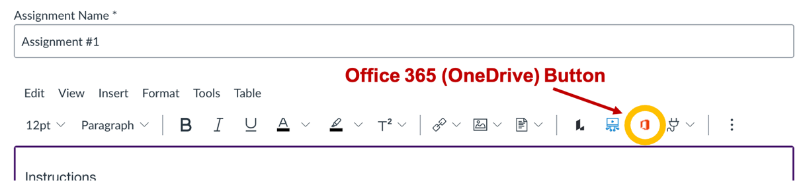

Add OneDrive File to a Module
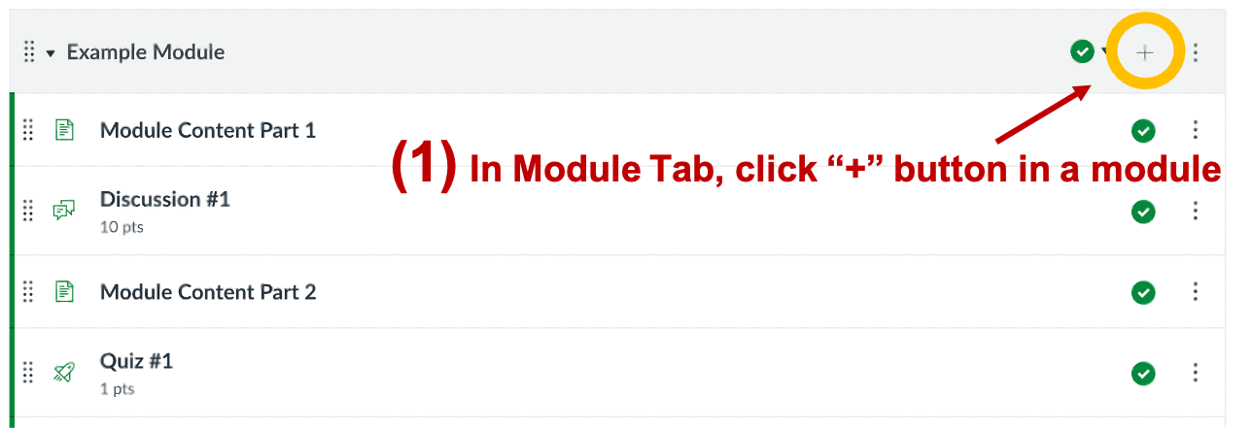

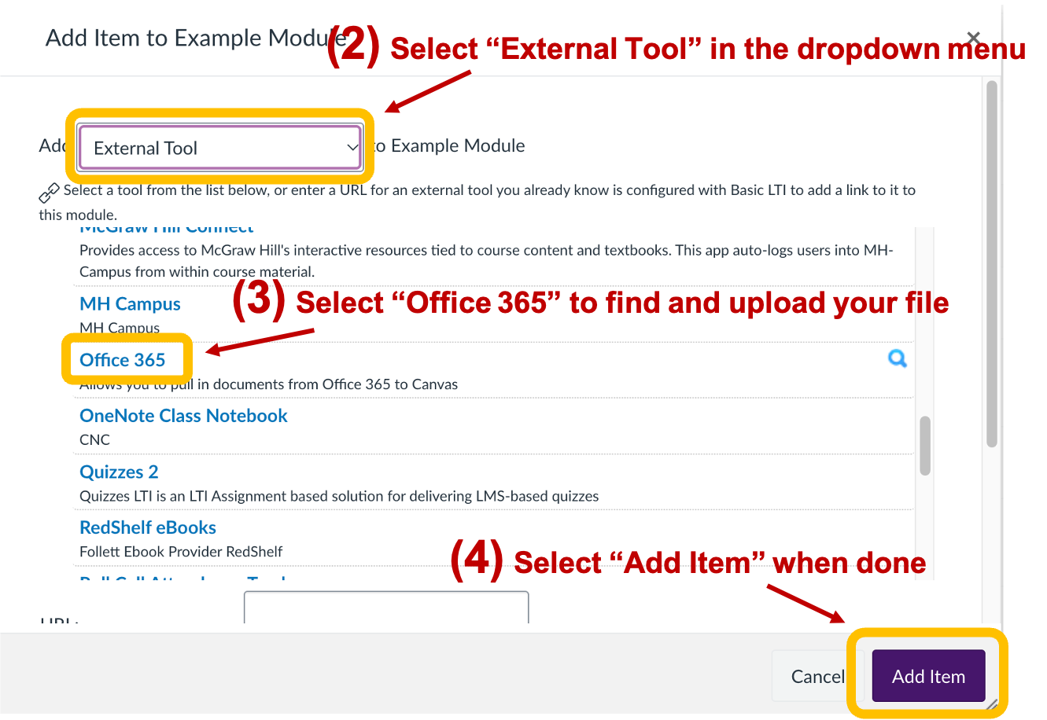

Additionally, Students have a limited amount of personal storage in Canvas. Items such as email attachments, profile pictures, and non-graded discussion uploads all affect a student’s personal storage. However, graded assignments and discussions do not impact student personal storage. It is strongly encouraged that student uploads be connected to graded activities to avoid students from hitting their storage limit.

Need Additional Help?
Canvas Support is available 24/7 (including evenings and weekends) to assist with all questions and concerns regarding the Canvas LMS. If you are experiencing any difficulties in using Canvas, contact Canvas Support by clicking the “Help” button at the bottom of the Canvas menu (purple bar on the far left in Canvas) and choosing one of the following options:
- Chat with Canvas Support (Faculty) – open a live chat with a Canvas support team member, meant for faculty
- Canvas Support Hotline – call to speak with a Canvas support team member via phone
- Report a Problem – submit a Canvas support ticket; before clicking this option, go to the location in Canvas where you are experiencing the problem

For questions about course design and training, please email the Center for Teaching and Learning (CTL) at ctl@una.edu. The CTL email is intended for Faculty use only. Please direct all student requests to the ITS Helpdesk or the Canvas Support process described above.

